**ECEN 325 - Lab Report**

**Lab Number: 2**

**Lab Title: Second Order Circuits**

**Section Number: 503**

**Student’s Name:** [Alex Allahar](mailto:alex.allahar@tamu.edu)

**Student’s UIN: 928009686**

**Date: 09/17/23**

**TA: Ángel Ocasio-Rodriguez**

1. **Measurements**
2. **Second Order Low Pass Filter Bode Plot**

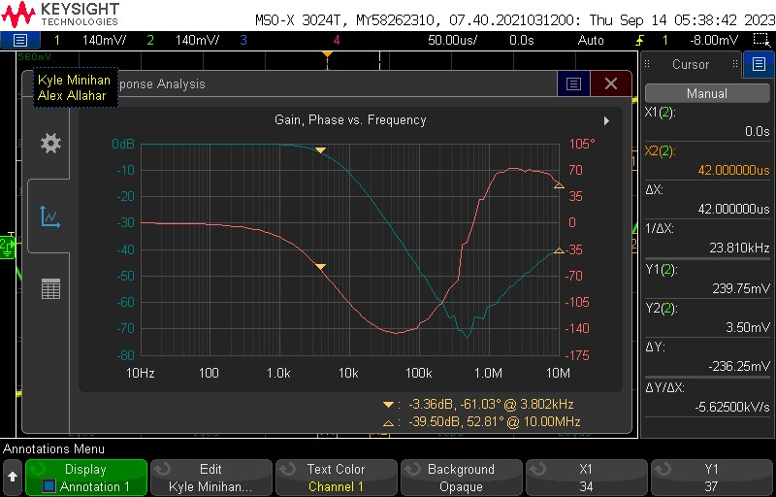

| **Measurements** | **Results** |
| --- | --- |
| **3-dB Frequency** | **3.802 kHz** |
| **Passband Gain** | **0 dB** |
| **Magnitude 5kHz** | **6 dB** |
| **Phase 5kHz** | **-78 °** |

1. **Second Order High Pass Filter Bode Plot**

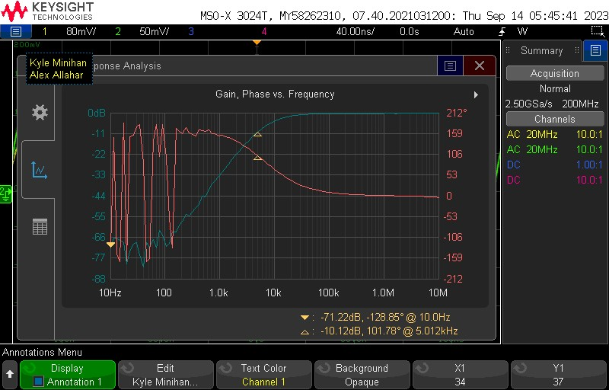

| **Measurements** | **Results** |
| --- | --- |
| **3-dB Frequency** | **10.5 kHz** |
| **Passband Gain** | **0 dB** |
| **Magnitude 5kHz** | **10.12 dB** |
| **Phase 5kHz** | **101.78 °** |

1. **Second Order Band Pass Filter Bode Plot**

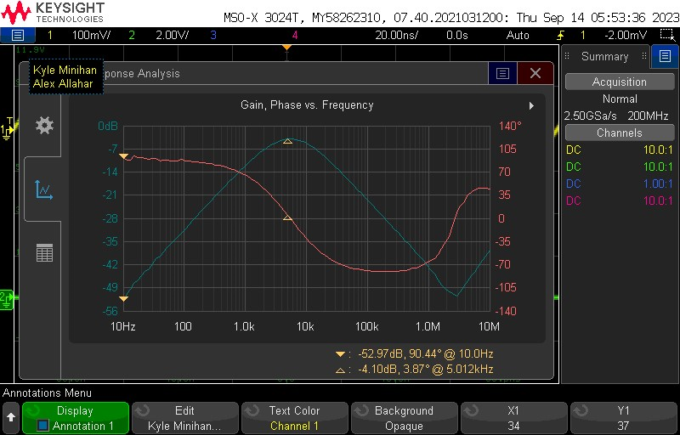

| **Measurements** | **Results** |
| --- | --- |
| **3-dB Frequency (Left)** | **2.188 kHz** |
| **3-dB Frequency (Right)** | **13.18 kHz** |
| **Passband Gain** | **-3 dB** |
| **Magnitude 5kHz** | **4.10 dB** |
| **Phase 5kHz** | **3.87 °** |

1. **Second Order Low Pass Filter Time-Domain Waveforms with Vi(t) = 0.5sin(2π5000t)**

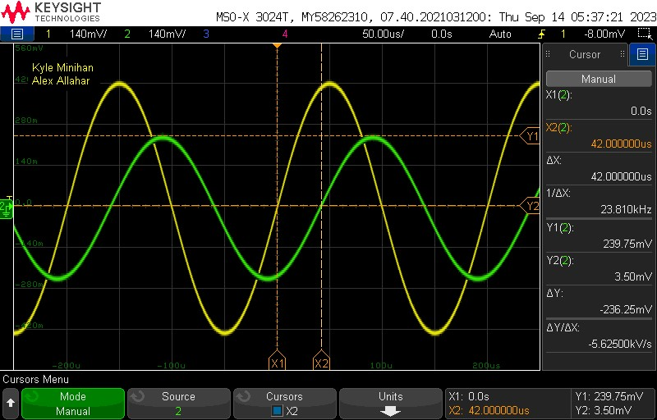

| **Measurements** | **Results** |
| --- | --- |
| **Input Voltage** | **420 mV** |
| **Output Voltage** | **239.75 mV** |
| **Phase Difference** | **75.6 °** |

1. **Second Order High Pass Filter Time-Domain Waveforms with Vi(t) = 0.5sin(2π5000t)**

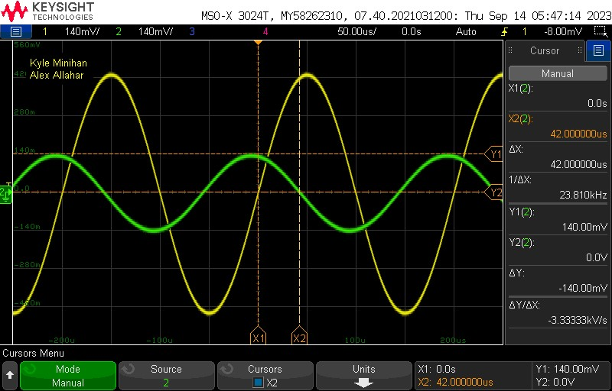

| **Measurements** | **Results** |
| --- | --- |
| **Input Voltage** | **420 mV** |
| **Output Voltage** | **140 mV** |
| **Phase Difference** | **75.6 °** |

1. **Second Order Band Pass Filter Time-Domain Waveforms with Vi(t) = 0.5sin(2π5000t)**

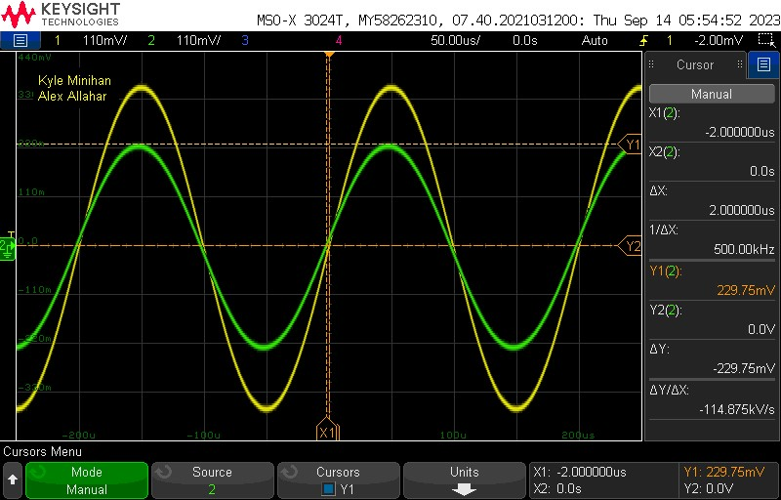

| **Measurements** | **Results** |
| --- | --- |
| **Input Voltage** | **400 mV** |
| **Output Voltage** | **229.75 mV** |
| **Phase Difference** | **3.6 °** |

**2.**

1. **Output Voltages Table**

|  | **Calculated** | **Simulated** | **Measured** |
| --- | --- | --- | --- |
| **LP Vout** | **51.914 mV** | **51.914** | **239.75 mV** |
| **HP Vout** | **104.23 mV** | **104.23 mV** | **140 mV** |
| **BP Vout** | **92.191 mV** | **92.191 mV** | **229.75 mV** |

**3.**

The main reason for the difference in the calculated, simulated, and measured values is the use of different resistors and capacitors during the experiment. For the calculations and simulations, the following resistors and capacitors were used: R1 =10 kΩ, R2= 1650 Ω, C1 = 33nF, C2 = 4.7nF, R3 = 3300 Ω, R4 = 5000 Ω, C3 = 33 nF, C4 = 4.7 nF, R5 = 33862.8 Ω, R6 = 33862.8 Ω, C5 = 33 nF, C6 = 4.7 nF. However, during the experiment, the following values were provided to ensure the graphs behaved in accordance: R1 =100 Ω, R2= 1 lΩ, C1 = 240nF, C2 = 33nF, R3 = 100 Ω, R4 = 1.8 kΩ, C3 = 220 nF, C4 = 20 nF, R5 = 200 Ω, R6 = 9990 Ω, C5 = 200 nF, C6 = 2 nF.

**4.**

During the lab, I tested my resistor and capacitor values and got similar Bode plots in the LP, HP, and BP. The transient waveforms were also okay; however, they were not as smooth as graphs when using the values provided. By trying both sets of R and C values, the same transfer function can be obtained with different R and C values. From the prelab equations, as long as the multiplication of R and C values are the same result any combination of R and C can be used and the transfer function remains the same. Due to the parts provided having fewer capacitors than resistors, starting by determining the capacitors' values, and then the resistors' values is a good approach.